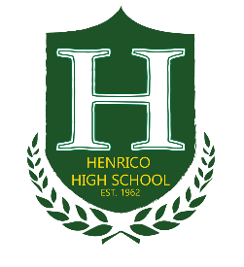
HENRICO HIGH SCHOOL PTSA CALENDAR of EVENTS
2015-2016 School Year

August
- PTSA Board Meeting, 25th @ 6PM @ Henrico HS.
- Freshman Orientation, 27th from 9:00AM - 12:00PM
September
- Fee nights 1st & 2nd from 3:30PM – 6:00PM.
- PTSA Board Meeting, 10th @ 6PM @ Henrico HS.
- Back to School Night & General Meeting, 21th from 6PM-9PM.
- Chipotle Spirit Night VA Center, 29th from 4PM – 9PM
October
- Breast Cancer Awareness Month (Wear Pink)
- PTSA Board Meeting, 13th @ 6PM @ Henrico HS.
- PTA District Training, 10th from 9AM-11:30AM.
- 3on3 Basketball Tournament, 10th @ 1pm.
- Senior Convocation 14th from 10am-11:30am.
November
- PTSA Board Meeting, 10th @ 6PM.
- Spirit Night- TBD
- Henrico HS Choral Concert @ 7pm.
December
- PTSA Board Meeting, 8th @ 6PM @ Henrico HS. Henrico HS Winter Band/Orchestra Concert @ 7pm.
January
- PTSA Board Meeting, 12th @ 6PM @ Henrico HS.
- Spirit Night - TBD
February
- PTSA Board Meeting, 9th @ 6PM @ Henrico HS.
March
- PTSA Board Meeting, 8th @ 6PM @ Henrico HS.
- Spirit Night

April
- PTSA Board Meeting, 12th @ 6PM @ Henrico HS.
May
- PTSA Board Meeting, 10th @ 6PM @ Henrico HS.
- Spirit Night - TBD
June
- PTSA Board Meeting, 7th @ 6PM @ Henrico HS.

